**Mobile Testing?**

* And Mobile Testing is the testing of the actual mobile device and focuses on mobile features like Call, SMS, Contacts, Media Player, inbuilt browsers etc.
* It is a mobile device feature testing
* We are not involved in mobile device testing.
* Mobile devices are tested in the factories where they were manufactured. Mobile devices are more hardware oriented

#### **Mobile app testing?**

* Mobile app testing is the testing of applications on a device which mainly focuses on functions and features of the application.
* Mobile application testing is a procedure to test mobile applications for usability, functional, and compatibility etc.
* Mobile apps are more software oriented (although even they need to be tested on different hardware devices)
* We are involved in mobile application testing.

# **Mobile Application Testing vs. Web Application Testing**

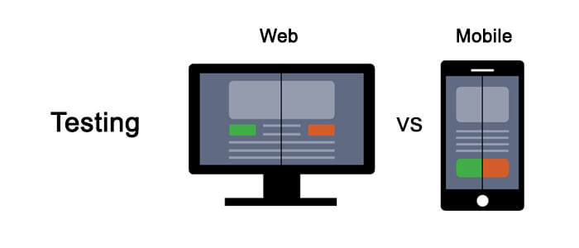

**Web Applications:**

The web application that runs within a browser!

This is the application which entirely resides on the server and to access the application, we need a platform i.e. browser.

So if any application runs on browser we can say its a web application.

Taking an example of one of the applications is Facebook which is having pages/modules which runs on a browser.

A web application is being used on various devices i.e. mobile, tablet and desktop with web-browser and internet connectivity.

These applications are developed using popular technologies like HTML, CSS, JavaScript, and are utilized through multiple browsers like Chrome, Safari, Firefox, etc.

web applications can also be viewed across multiple devices like mobiles, tablets, and desktops that provide active internet connections.

**Mobile Application:**

In the mobile application we have

* Native Application
* Mobile web Application
* Hybrid Application

#### 

#### **How Mobile application testing is different from web application testing or What are the challenges in mobile application testing?**

Some specific area’s we need to cover in mobile application testing but not in web-

* Screen resolution
* Turning on/off GPS
* Screen orientation (landscape, portrait)
* Different devices’ manufacturers
* Oss-Android,iOS etc
* Type of mobile application

### **Challenges for the mobile testing**

1. **Operating System Fragmentation:** Different mobile phones have different operating systems.

Fragmentation is a big issue for the Android application because the Android has 11 different operating systems.

The percentage of the iOS devices is 93% who are using version 9 or 10, so the fragmentation issue of Apple's Operating system for the iOS devices is less than the Android.

1. **Types of mobile apps:** There are the different types of the mobile apps,

these can be the native app, a web app, or a hybrid.

The testing of these applications is different from the other, so the implementation is also different from one another.

1. **Numerous Test Interfaces:** We use some testing tool like emulators and simulators if we dont have physical devices for testing and also perform regular Regression Testing.

The advantages of these tools are limited, and we cannot use these tools as a substitute for the real world.

1. **Multiple automation Testing tools:** In the market, we can find the automation tools in the wide variety, but here the challenging factor is to decide which tool is best for the mobile application testing.
2. **Battery:** Mobile apps demands lots of batteries.

Mobile apps consume more power. The use of multiple apps will drain the life of the battery.

The mobile application testing company should have to be focussed on the consumption of the power by mobile apps when designing the process of the testing.

1. **Change in users Requirement:** When the requirement of the user's change, then there is a need for frequent updates in the mobile application.

The challenge in the testing is increasing because the development environment is changing rapidly after building the product or fixing the bugs

1. **Mobile Networks:** People move from place to place to another. The network coverage is also changing.

In the underground places, the signals are weak. At the time of the boarding of flight and take-offs, in that case, signals are also disrupted.

Some apps need to work on the offline mode but still tester has the challenges to test the application under different networks.

1. **Usability:** The success of mobile apps depends on the usability of mobile apps(as how our application is user friendly and fit for use).

The well-designed apps have an attractive interface. We can access the content easily.

Navigation is also smooth. The image adjusts according to the size of the screen.

Users can access the feature within apps by the touch of the finger and also by the tapping.

#### **Types of Mobile Applications**

The type of mobile app you are testing plays a very important role in defining your testing process.

Three different types of mobile application testing:

1. **Mobile web applications**: These are the web pages that you open through the mobile browser.
2. **Native Apps**: These are the applications that are developed for one particular platform. (iOS, Android, Windows 10 M0bile, Tizen, BlackBerry etc).
3. **Hybrid**: It is an combination of mobile web app and Native App.

## **Mobile Web**

Web apps are actually websites that open in your smartphone with the help of a web browser and internet connectivity.

Mobile websites used by multiple people around the world.

* Example − [Tutorials Point](http://www.tutorialspoint.com/)
* Benefits −
  + Easy access.
  + Easy Development − Developing responsive design and displayed on a smaller screen/hardware will make any desktop website mobile friendly.
  + Easy update − Just update in one location and all the users
  + No installation required, as compared to native or hybrid app.
* Downside −
  + Mobile websites cannot use some of the features. For example, access to the file system and camera etc
  + Many existing websites don’t support offline capabilities.(means internet required)
  + Users won’t have the app’s icon on their home screen as a constant reminder. The website needs to be opened in a web browser only.
  + While native and hybrid apps appear on the App Store and Google Play, web apps won’t.

## Native App

A native app is developed specifically for one platform/OS. It can be installed through an application store (such as Google Play Store or Apple’s App Store).

* Example − Whatsapp, Facebook.
* Benefits −
  + Native Apps live on the device and are accessed through icons on the device home screen.
  + They can take full advantage of all the device features − they can use the camera, the GPS, the compass, the list of contacts, and so on.
  + Native apps can use the device’s notification system and can work offline.
  + Push-notifications, alerting users every time a new piece of content/text is published or when their attention is required to user.
  + Native Apps maintain UI design of each operating system thus they offer the best user experience.
  + For example, a Native App can have a left-aligned header in Android and a center-aligned header in iOS.
* Downside −
  + High cost for building the app : Native apps developed for one platform will not run on another platform.

An App built for Android will not run on iOS.

We need to build a different App altogether for iOS. Because of this reason, we need to maintain multiple versions of the App.

* + Costly to build Native apps

## Hybrid App

Hybrid Apps are a way to expose content from existing websites in App format. They can be well described as a mixture of Web App and Native App.

* Example − Instagram, Wikipedia.
* Benefits −
  + Developing a Hybrid App is cheaper than developing a Native App.
  + It can be built for cross-platforms, i.e., reduced cost for App development.
  + Maintenance is simple, as there are not many versions to be maintained.
  + It can take advantage of a few features available in the device.
  + It can be found in the App Store, playstore
  + It has a browser embedded within the app only.
* Downside −
  + Graphics/UI are less comparatively ,operating system as compared to Native Apps.
  + Hybrid Apps are slower than Native Apps.

**Difference between Mobile application types-**

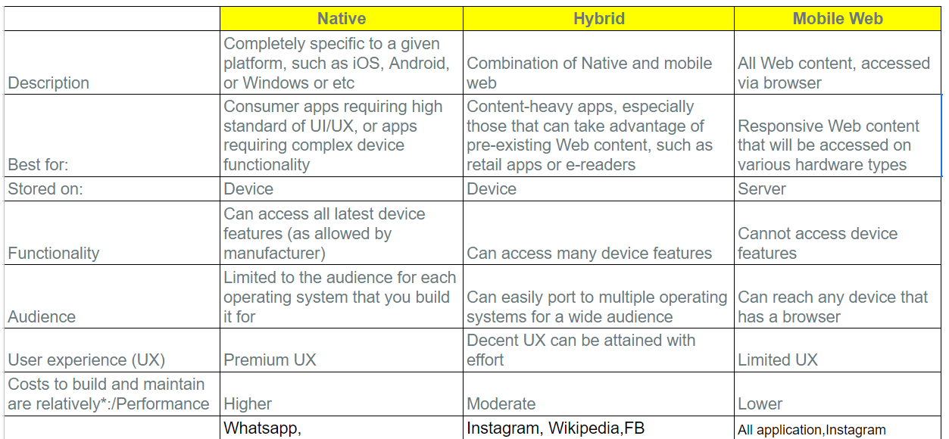

There are few basic differences that set these apart:

* Native apps have single platform affinity while mobile web apps have the cross-platform affinity.
* Native apps are written in platforms like SDKs while Mobile web apps are written with web technologies like HTML, CSS, asp.net, Java, PHP.
* For a native app, installation is required but for mobile web apps, no installation is required.
* A native app can be updated from the play store or app store while mobile web apps are centralized updates.
* Many native apps don’t require an Internet connection but for mobile web apps, it’s a must.
* Native app works faster when compared to mobile web apps.
* Native apps are installed from app stores like Google play store or app store where mobile web are websites and are only accessible through the Internet.

#### **Types of Mobile Application testing**

### 

**1) Functional Testing**

**2) Compatibility Testing**

**3) Memory Leakage Testing**

**4) Interrupt Testing**

**5) Usability testing**

**6) Installation Testing**

**7) Security testing**

**8) Recover-ability Testing**

**Functional Testing**

You have to do functional testing in order to make sure that your app is working as it is needed.

In the case of desktops, this is a type of black-box testing which aims at checking whether system function is proper as intended and can users operate it with ease.Same concepts we have t o use here.

**Memory Leakage Testing**

It’s important to perform the memory leakage test to make sure your app is utilizing balanced memory on different mobile devices.

When compared to computer systems, the inbuilt memory of a mobile device is very low. Most of the OS environments shut applications that are consuming too much memory.

So, testers must ensure that an app does not slow the mobile devices by performing mobile leakage testing.

**Interrupt Testing**

It’s natural that we face many interruptions while using an app.

Some of the common interruptions are receiving SMS or incoming calls, push notifications, inserting power cable when the app is running, etc.

To make sure that your app is able to withstand all these interruptions; a tester is supposed to perform interrupt testing in mobile devices.

**Usability testing**

The success of an app depends on its flexibility to use. A good app should be able to give amazing user experience to the customers.

To ensure that your app is user-friendly, usability testing services may help you.

This mostly deals as how your application is user friendly and FIT for use.

**Installation Testing**

It’s important to check the consistency of your app during installing and uninstalling processes.

Frequently crashing apps during these processes do not survive in the market.

Installation testing checks whether the software is compatible with the mobile and it does not affect the navigation or the flow of other apps.

Apps should be install properly and within the time limit and should not impact on phone.

**Security testing**

If an app is vulnerable to security threats, people hardly use that app. So, you have to ensure the credibility of your app by performing security testing services.

Security testing helps you in giving assurance to your customers that your app is free from security threats like data protection.

**Recover-ability Testing**

While recovery ability testing, crash recovery, and interruptions during transactions are tested.

Recovery ability testing mainly checks how an app works on transactions when there is an app failure.

This is same as web application.

**Compatibility Testing**

Compatibility Testing is performed on mobile phones to know whether the app works on different devices and on OS like android and iOS.

As there is a number of devices with different screen size, resolution, hardware and software functionality, versions, etc.

### **Important Checklist**

1. Installation testing (whether the application can be installed in a reasonable amount of time and with required criterion)
2. Uninstallation testing (whether the application can be uninstalled in a reasonable amount of time and with required criterion)
3. Network test cases (validation of whether the network is performing under required load or not, whether the network is able to support all the necessary applications during the testing procedures)
4. Check Unmapped keys
5. Check application splash screen
6. Continued keypad entry during interrupts and other times like network issues
7. Methods which deal with exiting the application
8. Charger effect while an application is running in the background
9. Low battery and high performance demand
10. Removal of battery while an application is being performed
11. Consumption of battery by application
12. Check Application side effects

## 

# Mobile Operating System

A mobile operating system is an operating system that helps to run other application software on mobile devices.

It is the same kind of software as the famous computer operating systems like Linux and Windows, but now they are light and simple to some extent.

The operating systems found on smartphones include Symbian OS, iPhone OS, RIM's BlackBerry, Windows Mobile, Palm WebOS, Android, and Maemo. Android, WebOS, and Maemo are all derived from Linux.

Now a days only Android and Ios are popular and mostly used for mobile devices.

## Popular platforms of the Mobile OS

1. **Android OS: The Android operating system is the most popular operating system today. It is a mobile OS based on the Linux Kernel and open-source software. The android operating system was developed by Google. The first Android device was launched in 2008.**

2. Bada (Samsung Electronics): Bada is a Samsung mobile operating system that was launched in 2010. The Samsung wave was the first mobile to use the bada operating system. The bada operating system offers many mobile features, such as 3-D graphics, application installation, and multipoint-touch.

3. BlackBerry OS: The BlackBerry operating system is a mobile operating system developed by Research In Motion (RIM). This operating system was designed specifically for BlackBerry handheld devices. This operating system is beneficial for the corporate users because it provides synchronization with Microsoft Exchange, Novell GroupWise email, Lotus Domino, and other business software when used with the BlackBerry Enterprise Server.

4. **iPhone OS / iOS: The iOS was developed by the Apple inc for the use on its device. The iOS operating system is the most popular operating system today. It is a very secure operating system. The iOS operating system is not available for any other mobiles.**

5. Symbian OS: Symbian operating system is a mobile operating system that provides a high-level of integration with communication. The Symbian operating system is based on the java language. It combines middleware of wireless communications and personal information management (PIM) functionality. The Symbian operating system was developed by Symbian Ltd in 1998 for the use of mobile phones. Nokia was the first company to release Symbian OS on its mobile phone at that time.

6. Windows Mobile OS: The window mobile OS is a mobile operating system that was developed by Microsoft. It was designed for the pocket PCs and smart mobiles.

7. Harmony OS: The harmony operating system is the latest mobile operating system that was developed by Huawei for the use of its devices. It is designed primarily for IoT devices.

8. Palm OS: The palm operating system is a mobile operating system that was developed by Palm Ltd for use on personal digital assistants (PADs). It was introduced in 1996. Palm OS is also known as the Garnet OS.

9. WebOS (Palm/HP): The WebOS is a mobile operating system that was developed by Palm. It based on the Linux Kernel. The HP uses this operating system in its mobile and touchpads.